USB-C Docking Station & Hub Product Catalog
Version for Global Clients
Table of Contents
Multi-Display DisplayLink Docking Stations (DC Series Professional Workstation Docks)
Portable Multi-Function USB-C Hubs (EZ/RU/PW/M2P Series)
Powered Data-Only USB Hubs (YH/C1 Series, No Video Output)
Special Functional Hubs (With M.2 SSD Enclosure, Stand, Magnetic Design)
Part 1: Professional DisplayLink Multi-Monitor Docking Stations
DC009-X1 | 14-in-1 USB-C Docking Station
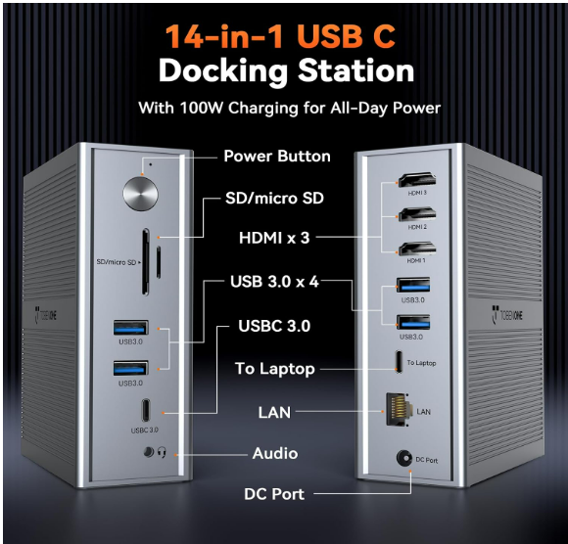

DC009-X1 14-in-1 Dock
Core Features
Triple 4K Display Expansion Powered by DisplayLink Tech
Turn your laptop into a full-featured workstation. Equipped with 3 HDMI ports, it supports up to 3 external monitors: 4K@30Hz single output or dual 1920×1200@60Hz extended displays. It perfectly solves the single-external-screen limitation of M1-M5 MacBook series, ideal for stock traders, coders and graphic designers who need multi-screen parallel viewing.
Break Cross-System Display Limits
Built-in DisplayLink chip bypasses native macOS & Windows display restrictions. Simply install free official drivers, then drive 3 external monitors via one single USB-C cable. Fully compatible with Thunderbolt 5/4/3, USB4 and full-function USB-C laptops, perfect for remote work, video editing & data analysis.
120W Built-in Power Adapter, 100W Laptop PD Charging
Different from ordinary USB-C docks, this model comes with a 120W DC power supply, delivering up to 100W pass-through PD fast charging for MacBook Pro, Dell XPS, ThinkPad and other notebooks. No need to carry your original laptop charger. Extra USB ports offer auxiliary charging for phones, tablets and portable SSDs.
5 High-Speed USB Ports + Gigabit Ethernet for Stable Connection
Includes 5 high-speed USB interfaces (USB-A + USB-C 3.0, 5Gbps bandwidth) to connect keyboards, mice, external hard drives and printers simultaneously. Integrated 1000Mbps RJ45 LAN port delivers faster, more stable wired network than Wi-Fi, lag-free for video conferences and large file transfers. Clean up your desktop with seamless dual/triple-screen setup.
DC36-C1 | Upgraded 18-in-1 Quad-Monitor Docking Station

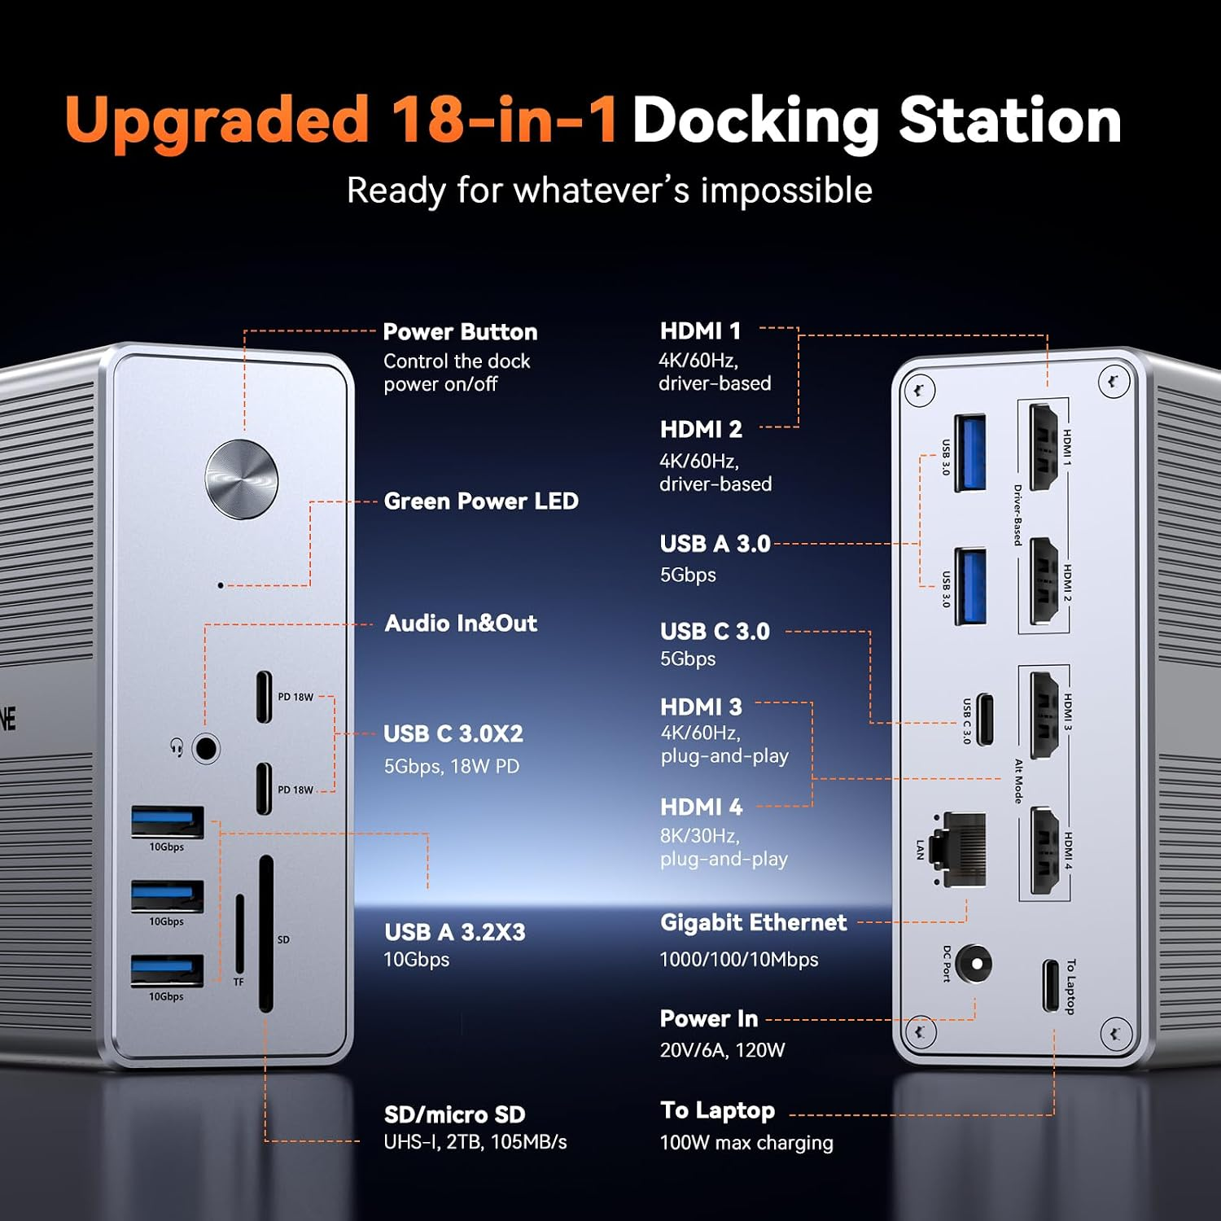
DC36-C1 18-in-1 Dock
Core Features
All-Round Rich Port Combination
This quad-display dock integrates 18 versatile ports: 4 HDMI outputs, 3×USB3.2, 2×USB3.0, 3×USB-C3.0, SD/microSD card reader, Gigabit Ethernet and 3.5mm audio jack. It covers all peripheral connection demands to streamline your workflow and boost office efficiency, whether working from home or in corporate offices.
Maximize Multi-Screen Productivity
Equipped with 4 HDMI ports to unlock full multi-tasking potential. Windows laptops support up to 4 external monitors; MacBook Pro/Air/Neo support up to 3 displays (Note: Only one of HDMI3/HDMI4 can be activated under macOS). All ports support crisp 4K@60Hz resolution for smooth, immersive visual performance.
Convenient Dual-Range PD Charging
Comes with a 120W power adapter, supplying up to certified 100W fast charging for Windows notebooks and MacBooks. Front USB-C port provides extra 18W quick charge for smartphones, so you can leave extra chargers at home or travel bags for a tidier workspace.
Wide Cross-Device & Cross-OS Compatibility
Supports laptops with USB4, Thunderbolt 5/4/3 and full-function USB-C ports, compatible with Windows 10+, Chrome OS 100+, Android, macOS 11+ and Ubuntu. Not compatible with Linux/Unix. DisplayLink driver installation is required for multi-screen output.
DC36-X1 | 18-in-1 Quad Display Docking Station (HDMI + DP Dual Video Output)

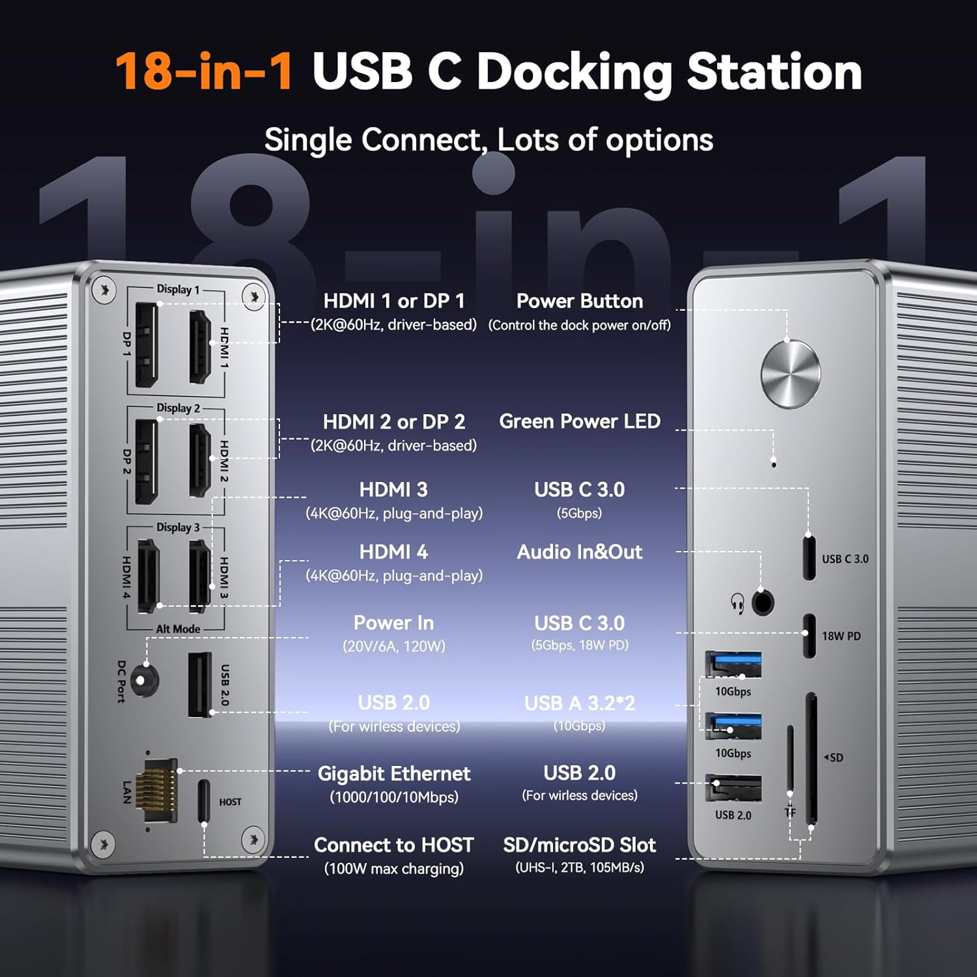
DC36-X1 18-in-1 Dock
Core Features
Professional Integrated Port Layout
Premium multi-screen dock with 18 multifunctional interfaces: 4 HDMI + 2 DP video outputs (support up to 4 external monitors), 2×USB3.2, 2×USB2.0, 2×USB-C data ports, SD/microSD reader, Gigabit LAN and audio jack. One single cable connects all peripherals to eliminate messy desktop cables, tailored for Thunderbolt 3/4 laptops, video editors and programmers.
DisplayLink Multi-Monitor Driving Technology
With DisplayLink chip solution, Windows devices can drive up to 4 external monitors, while MacBooks support up to 3 screens. Expand your desktop space to view spreadsheets, coding windows, design canvases and video calls side-by-side without constant window switching, a must-have for financial traders, developers and video creators.
100W Laptop PD + 18W Mobile Auxiliary Charging
Powered by a 120W built-in adapter, it delivers stable 100W fast charging for Windows and Mac notebooks (96W certified). Front USB-C port offers 18W charging for mobile devices, cutting down extra power accessories for travel and daily desk organization.
Universal System Compatibility
Works seamlessly with Windows 10+, MacBook/Mac Mini/MacBook Neo, Android, Chrome OS 100+, macOS 11+ and Ubuntu; supports Thunderbolt 3/4/5 & USB4 full-function USB-C devices. Linux/Unix systems are not supported. DisplayLink drivers are mandatory before use.
DC47-X3 | 18-in-1 Triple 4K Display Docking Station for Windows/Chrome OS
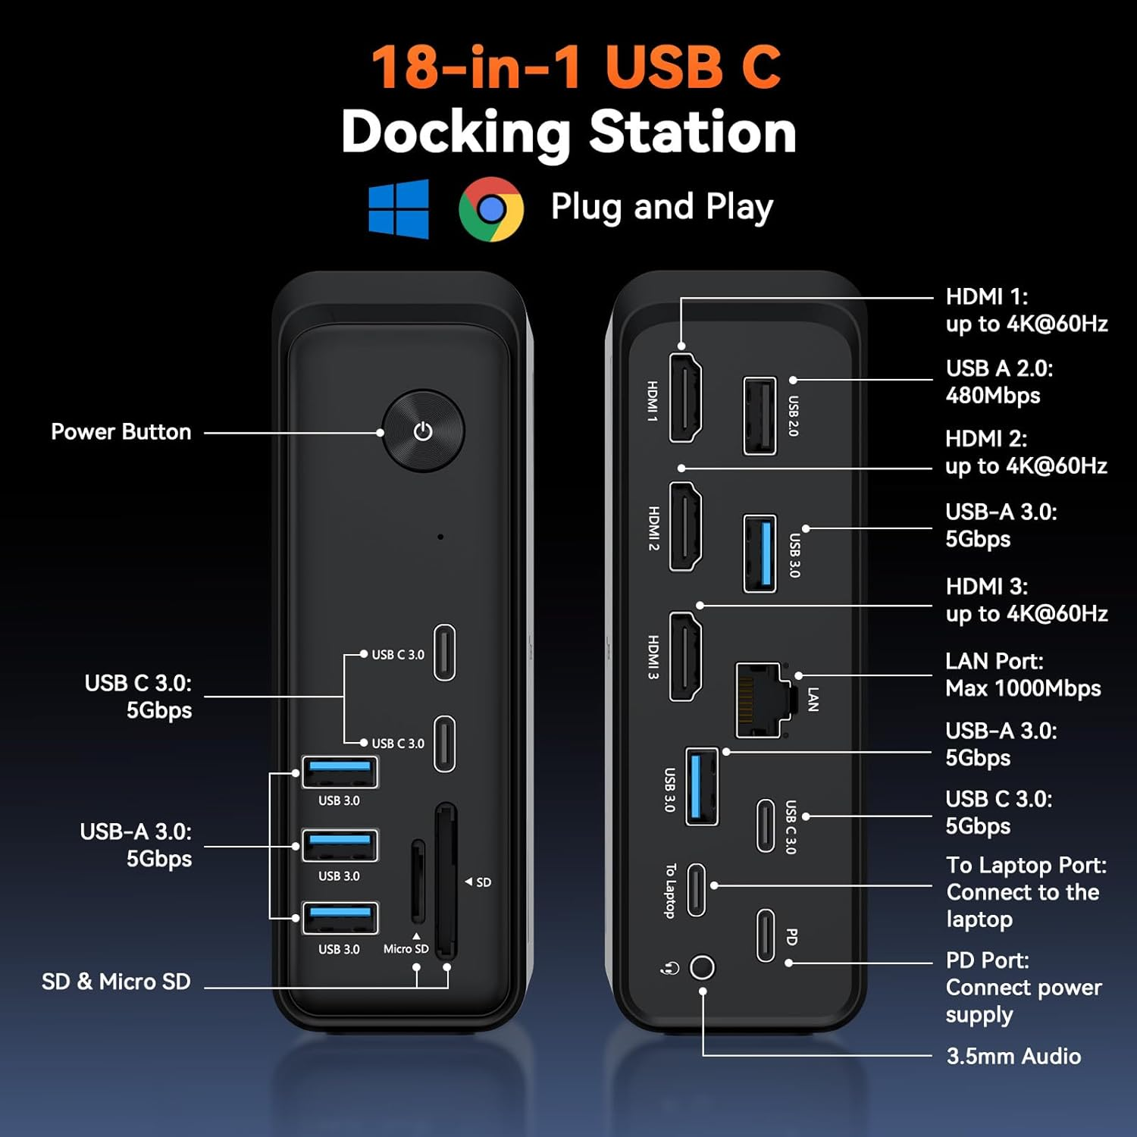
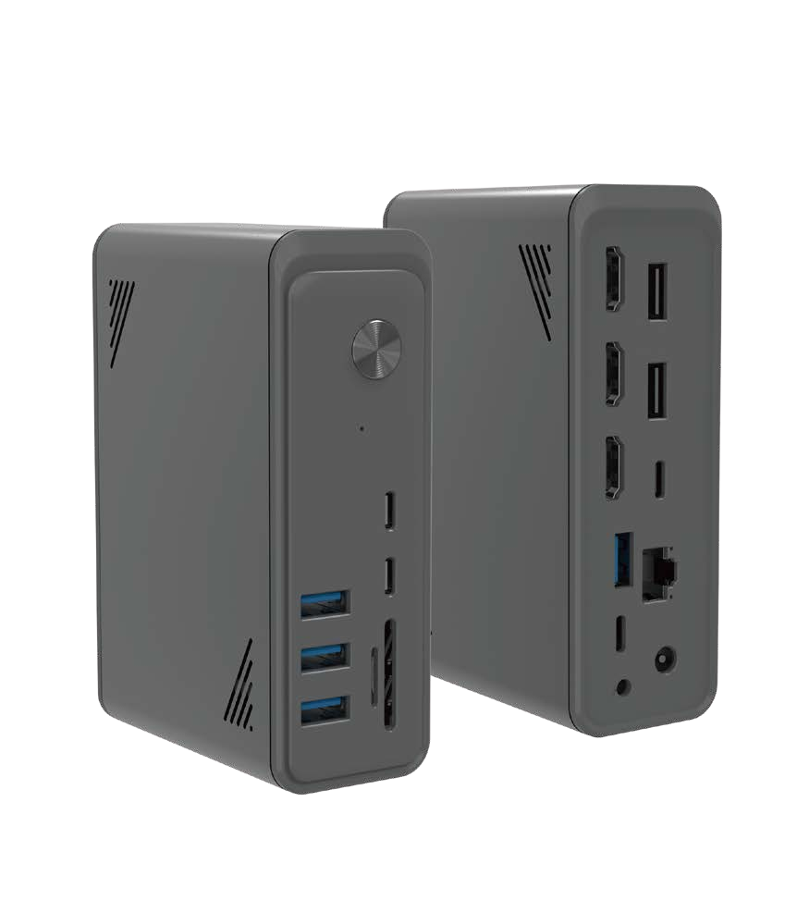

DC47-X3 18-in-1 Dock
Core Features
18-in-1 All-in-One Expansion Hub
Equipped with 18 functional ports: 9×USB/PD/host ports, 3×HDMI 4K@60Hz video outputs, Gigabit RJ45 LAN, SD/microSD card reader and 3.5mm audio jack. Transforms your laptop into a powerful workstation with clean cable management for home office & design workflows.
Smooth Triple/Dual 4K@60Hz Display Output
Support dual or triple extended monitors at 4K@60Hz with zero lag for simultaneous video editing, spreadsheet analysis and video conferencing.
9 USB Ports for Full Peripheral Connection
Massive USB capacity to connect keyboards, mice, external SSDs, printers and other peripherals all at once, an all-in-one hub for busy office and home workstations.
100W Continuous PD Charging & Targeted OS Compatibility
Sustained 100W pass-through charging keeps your laptop powered all day long, avoiding unexpected power loss during work. Optimized for Windows and Chrome OS laptops (Dell, Lenovo, HP, ThinkPad with full-function USB-C ports), the ultimate expansion solution for office & entertainment hybrid use.
DC45 | 20-in-1 DisplayLink Quad 4K Docking Station

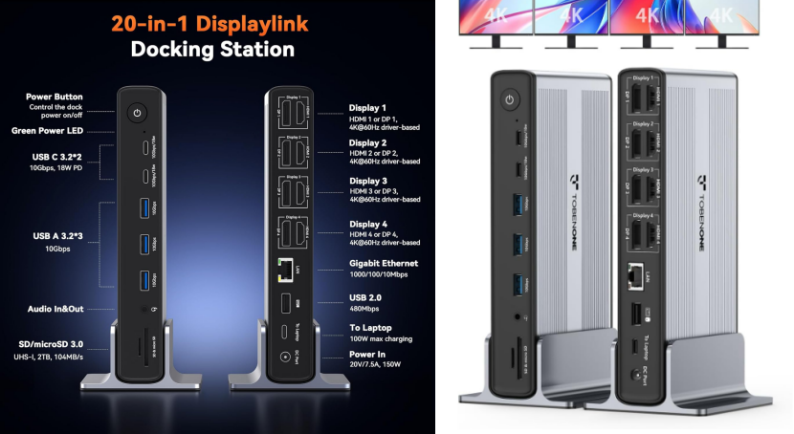
DC45 20-in-1 Dock
Core Features
20 Ports Max Expansion, All-Round Connection
Premium professional dock with 20 integrated ports: 4 HDMI + 4 DP video interfaces, 3×USB3.2, 2×USB-C3.2, 1×USB2.0, SD/microSD card reader, Gigabit Ethernet and audio jack. Independent power switch controls all connected peripherals, built for heavy multi-tasking creative and financial work.
Quad 4K@60Hz Multi-Screen Output
Upgraded DisplayLink solution supports 4 external monitors simultaneously. Windows notebooks fully support 4 displays; M-series MacBooks support maximum 3 external screens. All video ports deliver fluid 4K@60Hz resolution for lag-free multi-tasking.
150W Power Supply, Dual-Range PD Charging
Comes with a 150W DC power adapter, providing stable 100W PD charging for compatible USB-C laptops. Separate USB-C auxiliary port supplies up to 18W fast charging for smartphones, ideal for clutter-free office and travel setups.
Cross-Device & Cross-Platform Compatibility
Compatible with Windows 10+, MacBook/Mac Mini/MacBook Neo, Android, Chrome OS 100+, macOS 11+ and Ubuntu; supports Thunderbolt 3/4/5 & USB4 Type-C devices. DisplayLink drivers required before operation; HDCP function is not supported.
DC46×1 | 14-in-1 Vertical Docking Station
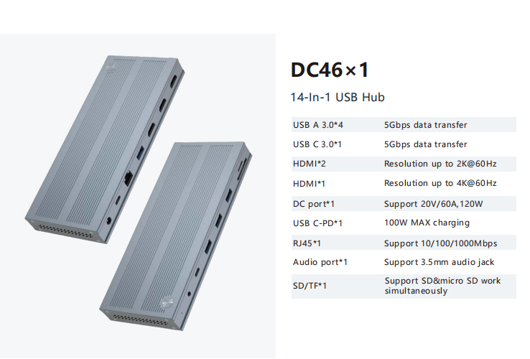

DC46×1 14-in-1 Dock
Core Features
Vertical vertical tower design saves desktop space with premium brushed aluminum casing for efficient heat dissipation.
Port layout: 4×USB3.0 5Gbps, 1×USB-C3.0 5Gbps, 3×HDMI (2K@60Hz + 4K@60Hz), 120W DC power input, 100W max PD pass-through charging, Gigabit LAN, 3.5mm audio jack, dual SD/microSD card reader (simultaneous read/write).
Built-in 120W power supply delivers stable power for multi-screen output and multiple peripherals running at the same time, widely used for trading rooms, design studios and remote office workstations.
Part 2: Portable Multi-Function USB-C Hubs (No Independent DC Power Adapter Included)
EZ02 | 15-in-1 Dual HDMI Docking Hub with Physical Volume Knob
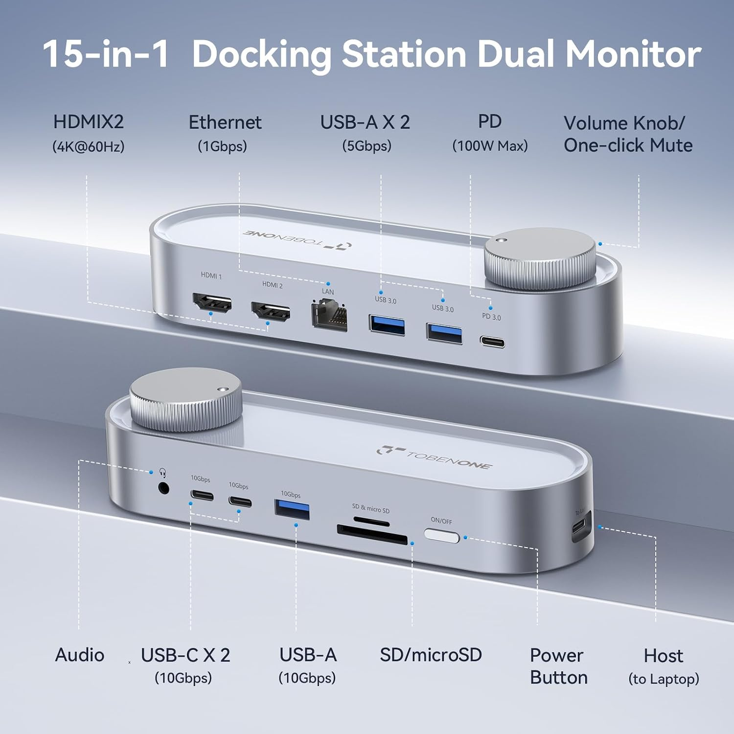

EZ02 15-in-1 Hub
Core Features
Dual 4K@60Hz HDMI Monitor Expansion
Two HDMI ports support 4K@60Hz dual-screen setup, building a triple-screen workspace together with your laptop’s native display. Perfect for developers, graphic designers and finance analysts to split email, document and reference windows without frequent tab switching. Note: Extended display mode is unavailable under macOS (mirror mode only).
Exclusive Physical Volume Control Knob
Unique one-click mute & volume adjustment knob eliminates the hassle of navigating system audio settings. Ideal for frequent video conference users, content creators and office staff who need instant audio tuning.
100W PD Pass-Through Charging (Power Adapter Not Included)
PD port supports up to 100W pass-through charging for laptops. Simply connect your own 65W+ USB-C charger to the hub to power the dock and notebook simultaneously via one cable, perfect for long coding, design and video conference sessions.
15-in-1 All-Round Daily Expansion
5 high-speed USB ports (2×USB-C 10Gbps, 1×USB-A 10Gbps, 2×USB-A3.0 5Gbps), dual SD/microSD card reader, Gigabit Ethernet and 3.5mm audio jack. Stable wired network ensures smooth cloud collaboration and video calls, while the audio knob delivers convenient instant sound control.
RU4A-HDV | 11-in-1 USB-C Travel Hub (HDMI + VGA Dual Video)
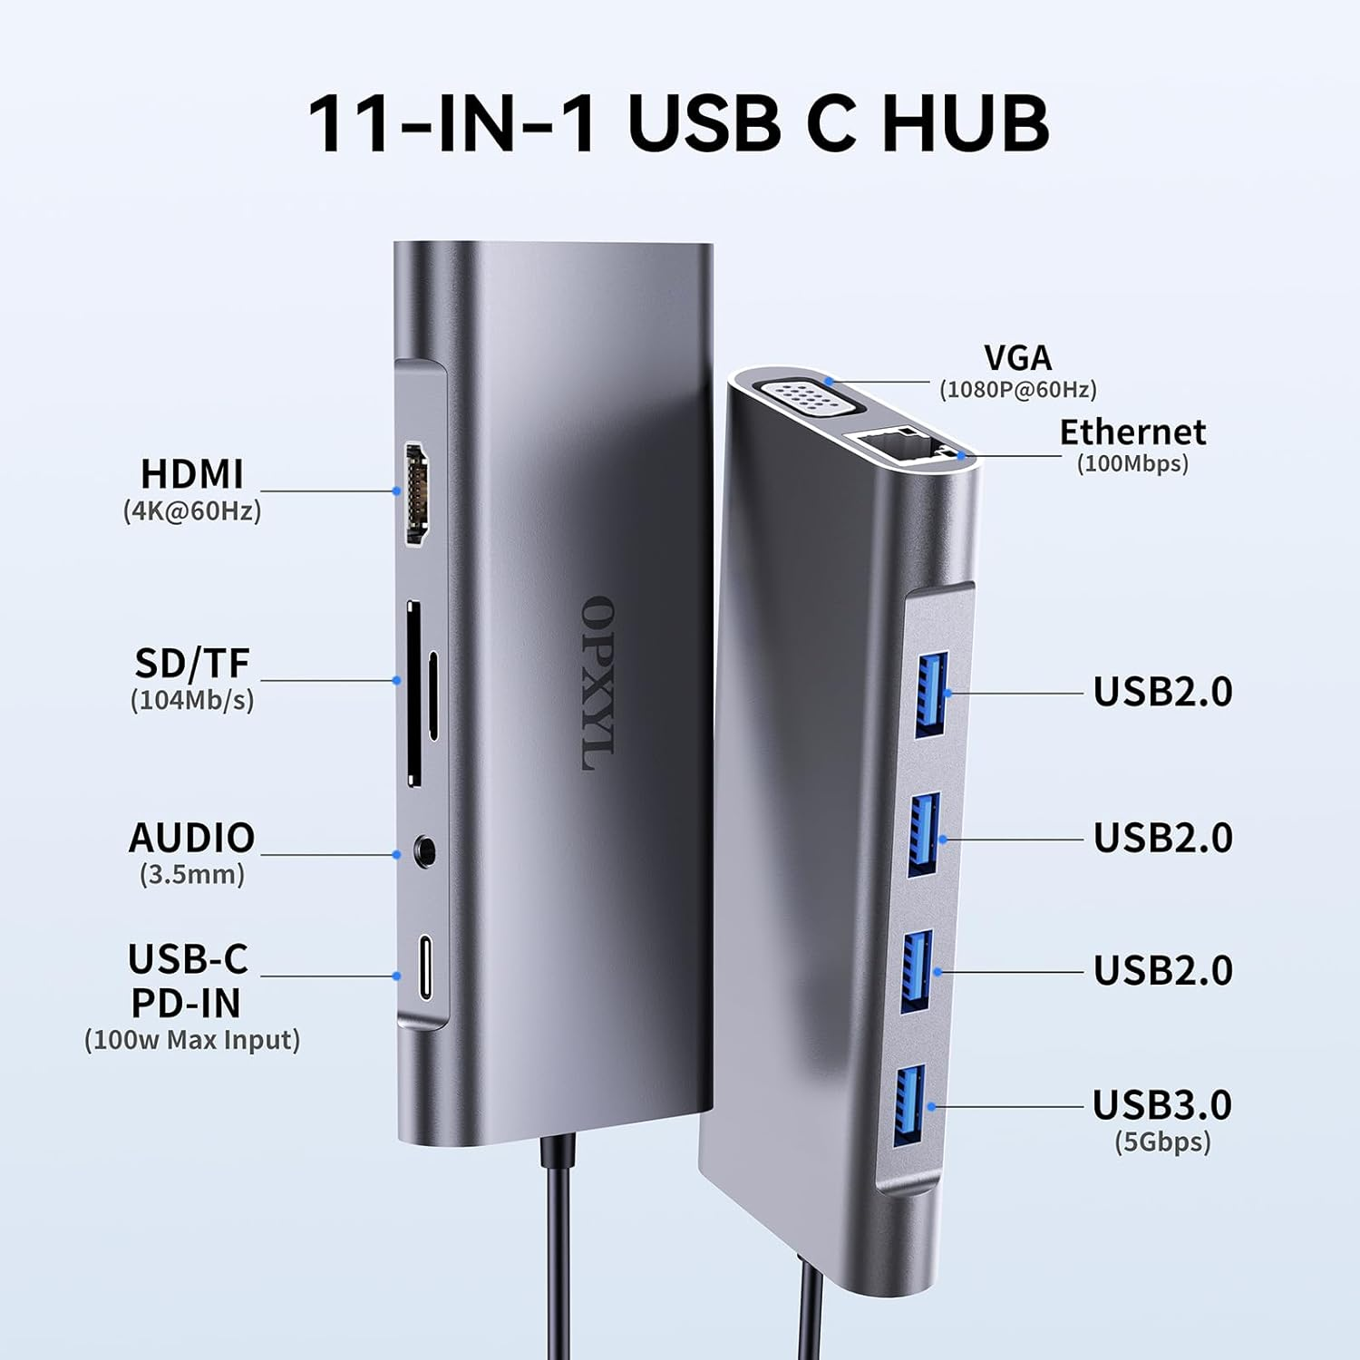

RU4A-HDV 11-in-1 Hub
Core Features
11 Ports Ultra-Portable Travel Hub
Expand one USB-C port into 11 practical interfaces: 1×HDMI 4K@60Hz, 1×VGA 1080P@60Hz, 1×USB3.0 5Gbps, 3×USB2.0, 1×100W PD charging, 100Mbps Ethernet, SD/TF dual card reader and 3.5mm audio jack. More complete than standard 7/9-in-1 hubs, optimized for business trips and remote work.
HDMI + VGA Dual-Screen Mirror/Extended Output
Supports simultaneous HDMI 4K and VGA 1080P display for presentations, video editing and multi-tasking office work.
Max 100W PD Input (87W Safe Output)
PD port accepts up to 100W charger input, safely outputting 87W to power your MacBook Pro, Windows laptops and Type-C devices. 65W+ chargers recommended for optimal performance.
Multi-Speed Data Transfer & Stable Wired Network
1×USB3.0 5Gbps + 3×USB2.0 for fast file transfers and low-power peripherals; dual card readers enable photographers to quickly import footage. 100Mbps RJ45 port delivers reliable wired internet for gaming, video calls and large file downloads.
Durable Aluminum Compact Design
Integrated aluminum alloy shell for superior heat dissipation and durability, ultra-slim form factor fits easily into laptop bags, compatible with MacBook, Dell XPS, Surface, HP, Chromebook across Windows/macOS/ChromeOS/Linux.
P9R-PRO | 10-in-1 High-Speed USB-C Hub with HDMI & Gigabit LAN

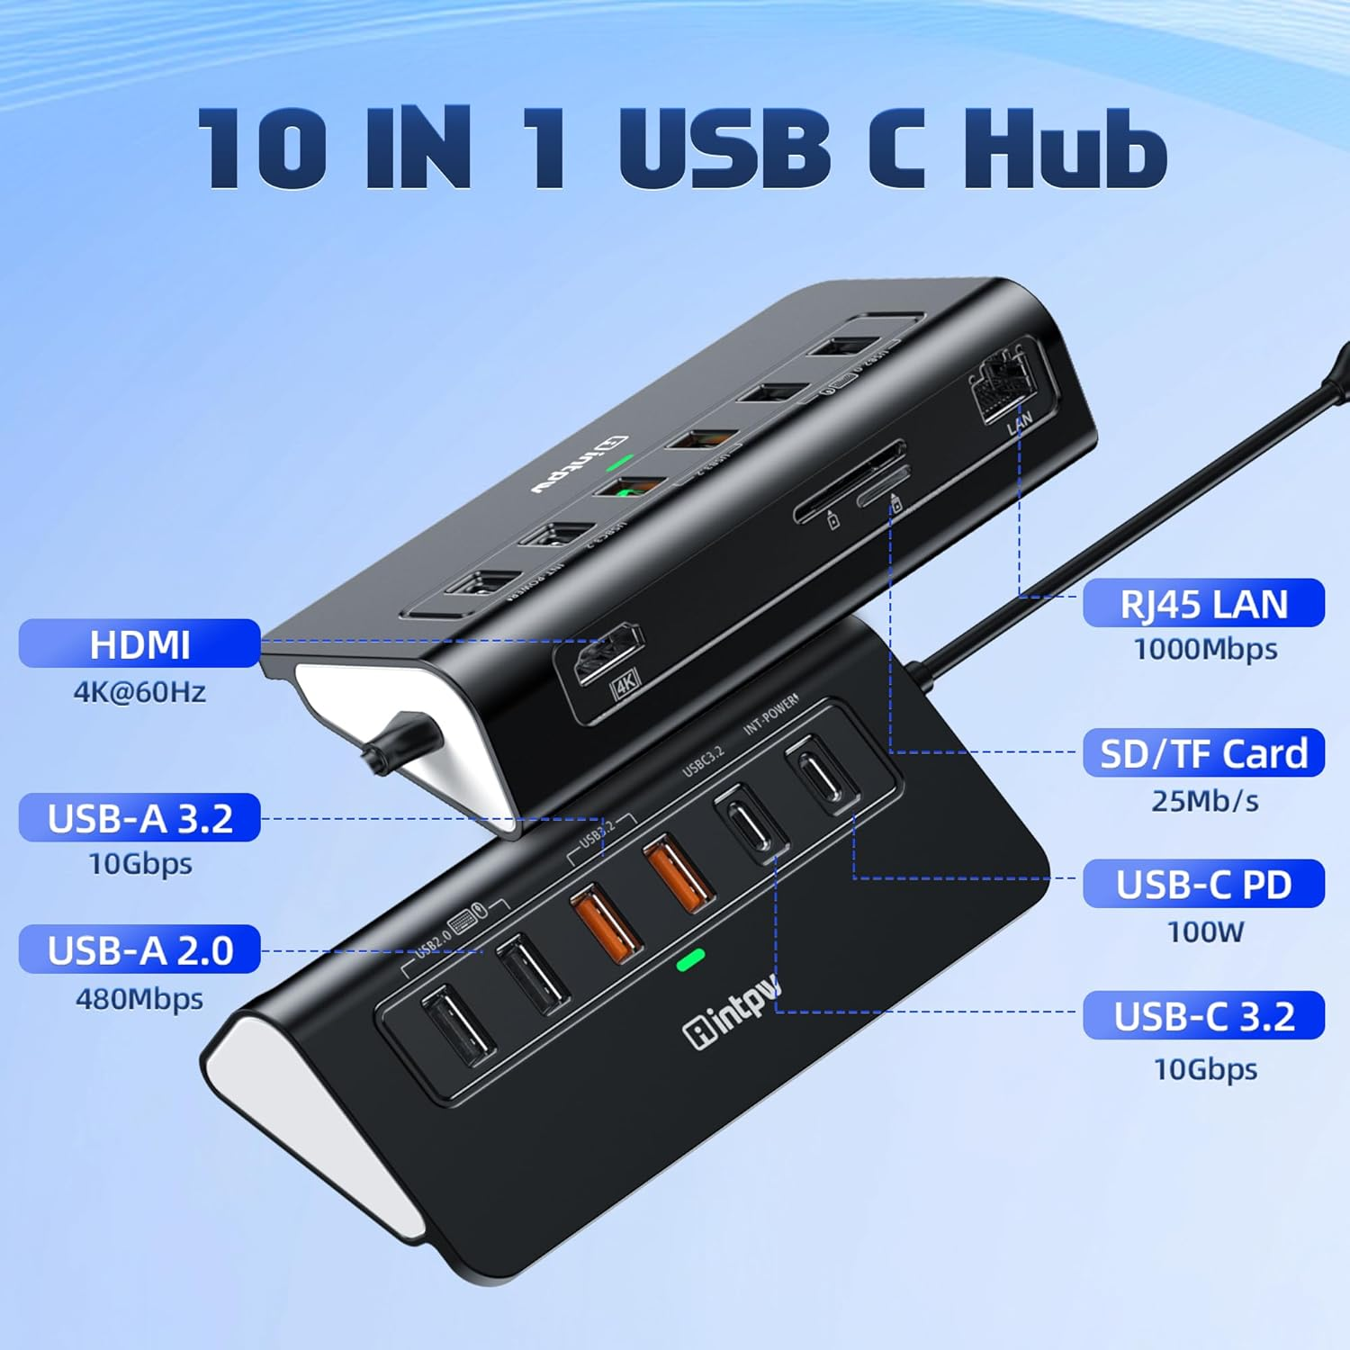
P9R-PRO 10-in-1 Hub
Core Features
10-in-1 Multi-Functional Integrated Hub
All essential daily ports integrated: 4K@60Hz HDMI, 1000Mbps Gigabit Ethernet, USB-C 3.2 10Gbps, 2×USB-A3.2 10Gbps, 2×USB-A2.0, 100W PD pass-through charging, SD/TF dual card reader (cannot read two cards at once). Assign USB2.0 ports for wireless keyboards/mice to avoid 2.4G signal interference.
10Gbps Ultra-Fast Data Transmission
3×10Gbps high-speed USB ports cut transfer time for large videos and raw photo files drastically. USB-C 3.2 port is data-only, no charging or video output function.
Stable Gigabit LAN & 100W PD Charging
1000Mbps wired network eliminates Wi-Fi lag for streaming and bulk downloads. PD port delivers full-speed laptop charging when paired with a 65W+ Type-C power adapter (laptop USB-C port must support PD protocol).
4K@60Hz Video Output & Ergonomic Aluminum Build
Crisp 4K 60Hz display output for meetings, education and creative work (host device needs DP Alt Mode or Thunderbolt). 32° tilted aluminum design with anti-slip rubber mats for easy plug/unplug, 50cm built-in USB-C host cable for flexible desk placement.
Wide Cross-Device Compatibility
Fits MacBook M1/M2/M3, iPad Pro, iPhone 15/16/17 and all full-function USB-C notebooks. Avoid unplugging PD chargers during use to prevent screen blackout or data loss.
PW11-8PH | 8-in-1 Dual HDMI Portable Hub

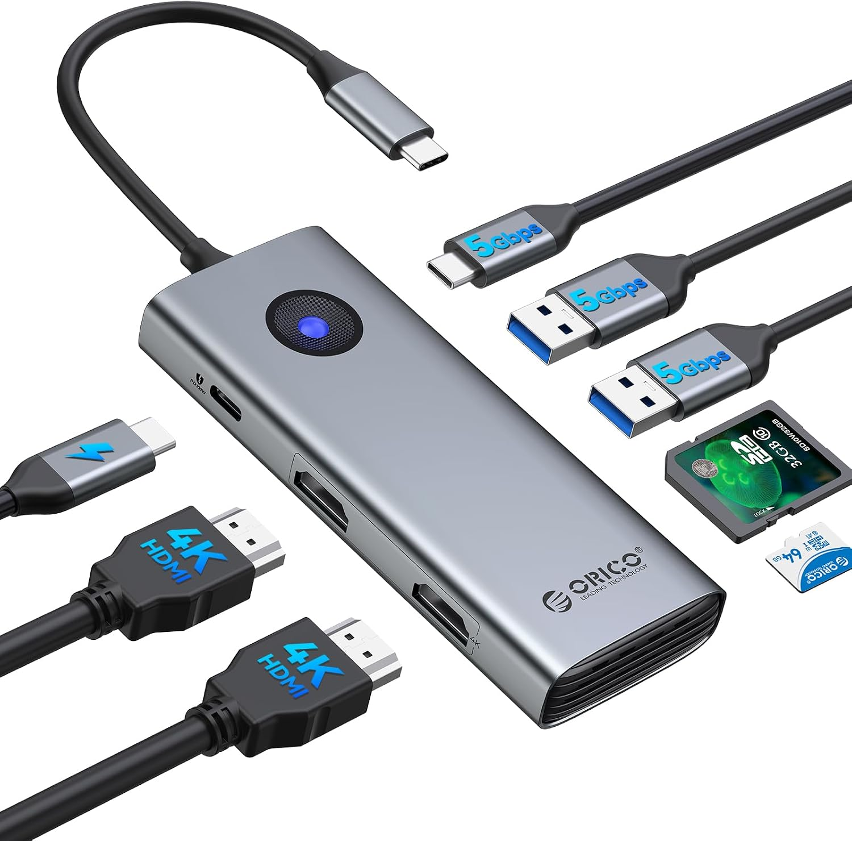
PW11-8PH 8-in-1 Hub
Core Features
8-in-1 Compact Expansion
2×HDMI 4K@60Hz, 2×USB-A 5Gbps, 1×USB-C 5Gbps, SD/TF dual card reader (simultaneous read), 100W PD pass-through charging. Connect monitors, SSDs and peripherals all at once with minimal cable clutter.
Dual 4K@60Hz Independent Display
Two HDMI 2.0 ports support dual extended monitors for design, financial monitoring and video editing. Note: macOS only supports mirror mode, not independent extended dual screens. Host, cable and monitors must support HDMI 2.0 for full 4K 60Hz performance.
5Gbps Data & Dual Card Reader
USB-A/C ports deliver 5Gbps file transfer speeds; SD/TF slots support simultaneous read/write up to 104MB/s for photographers to import raw footage rapidly.
100W PD Pass-Through Charging
Charge your Type-C notebook while expanding peripherals, ideal for mobile office. Power adapter not included; laptop USB-C port must support PD charging protocol.
Cross-Platform Plug-and-Play Compatibility
Works with Windows, macOS, Linux, Android and iOS, compatible with MacBook, iPad Pro, Dell XPS and all mainstream Type-C devices, no driver installation required.
RU Series Slim Travel Hubs (RU12A-D / RU28A-9P)

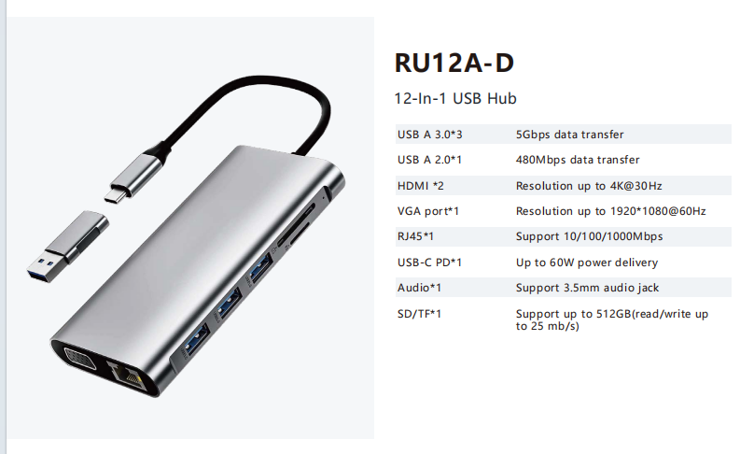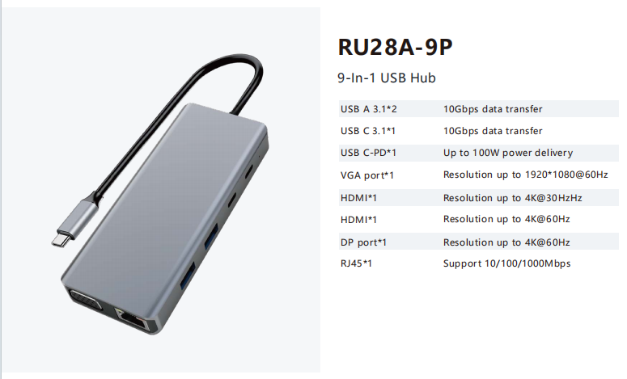
RU12A-D | 12-in-1 USB-C Hub
Ports: 3×USB-A3.0 5Gbps, 1×USB-A2.0 480Mbps, 2×HDMI (4K@30Hz), 1×VGA 1080P@60Hz, 1×Gigabit RJ45, 1×USB-C PD (60W max), 3.5mm audio jack, SD/TF card reader (512GB max, 25MB/s read-write).
Ultra-slim aluminum body, built-in short host cable, perfect for business carry-on.
RU28A-9P | 9-in-1 High-Speed Triple Video Hub
Ports: 2×USB-A3.1 10Gbps, 1×USB-C3.1 10Gbps, 100W PD charging, 1×VGA 1080P, 2×HDMI (4K30 + 4K60), 1×DP 4K60Hz, Gigabit Ethernet.
Supports triple video output, high-speed 10Gbps data ports for creative file workflows.
FK Series Budget Lightweight Hubs (FK01-9P25R / FK01-10P)

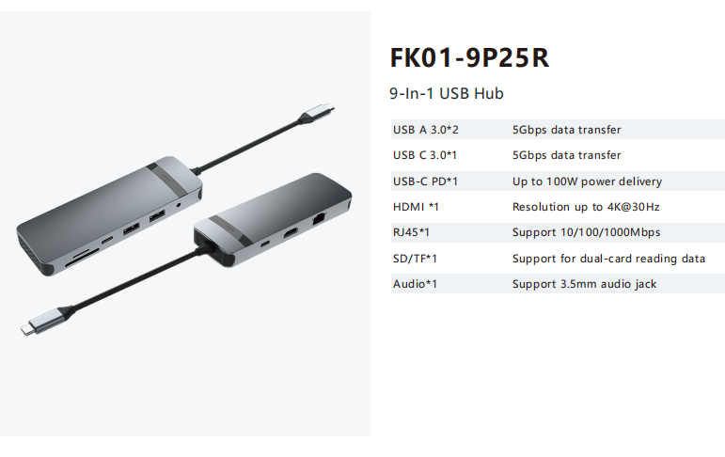
FK01-9P25R | 9-in-1 Basic Office Hub
2×USB-A3.0, 1×USB-C3.0, 100W PD, 1×HDMI4K30, Gigabit LAN, dual SD/TF reader, 3.5mm audio jack, plug-and-play for daily office use.
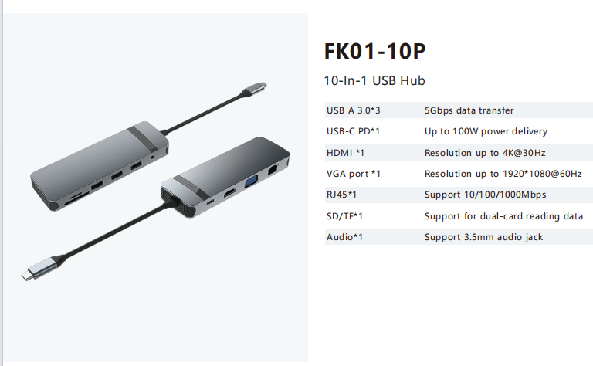
FK01-10P | 10-in-1 HDMI+VGA Dual Video Hub
3×USB-A3.0, 100W PD, HDMI 4K30 + VGA 1080P, Gigabit LAN, dual card reader, audio jack, ideal for classroom & meeting room presentations.
Other Compact Travel Hubs (28W-4 / U002 / RU32A-9P25R / 28PR)

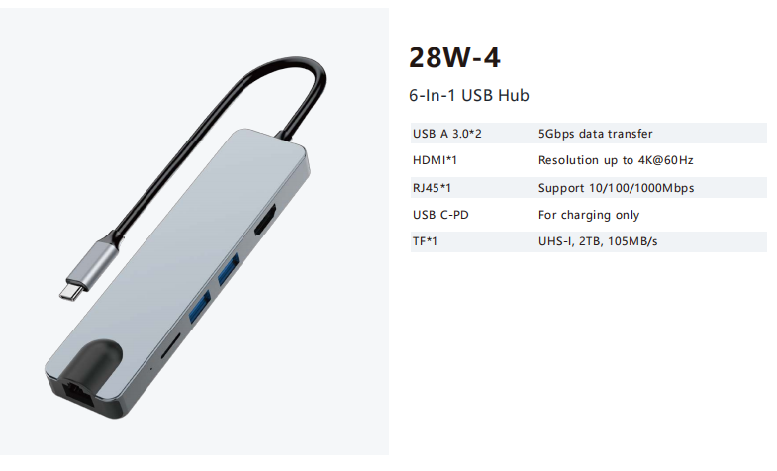
28W-4 | 6-in-1 Mini Hub: 2×USB-A3.0, HDMI4K60, Gigabit LAN, PD charging port, TF card reader (2TB max UHS-I).
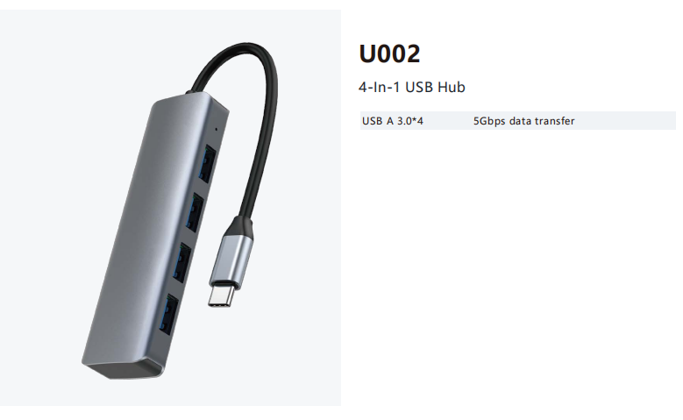
U002 | 4-in-1 Pure USB Splitter: 4×USB-A3.0 5Gbps, ultra-slim pocket-sized hub for expanding extra USB ports only, no video/charging functions.
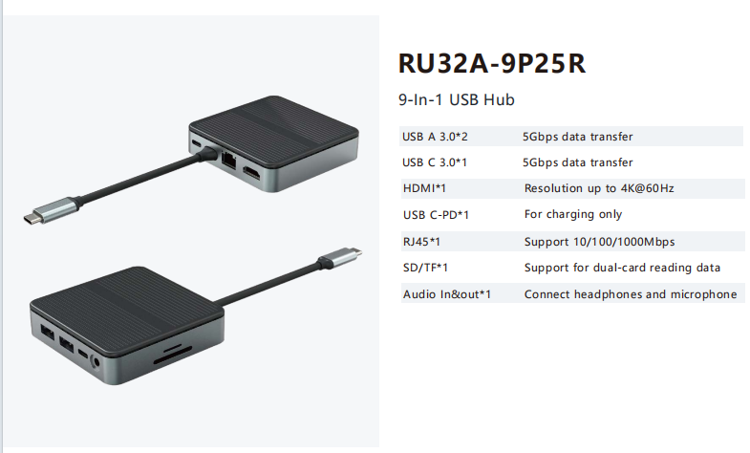
RU32A-9P25R | Square 9-in-1 Hub: Square compact chassis, 2×USB-A3.0, 1×USB-C3.0, HDMI4K60, PD charging, Gigabit LAN, dual card reader, 3.5mm combo audio in/out jack.
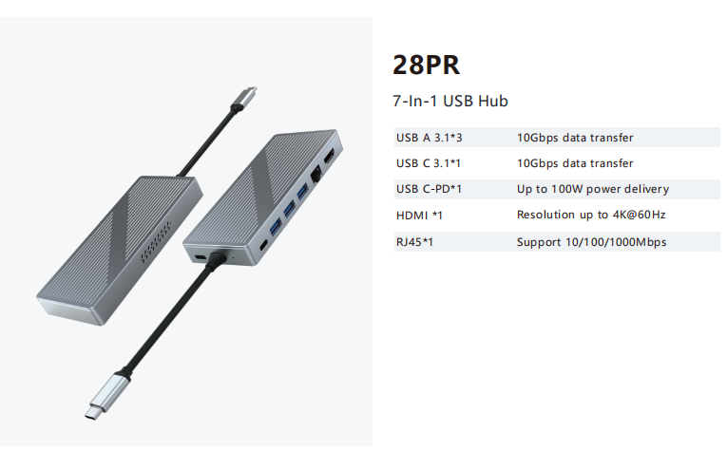
28PR | 7-in-1 High-Speed Hub: 3×USB-A3.1 10Gbps, 1×USB-C3.1 10Gbps, 100W PD, HDMI4K60, Gigabit Ethernet, balanced speed & portability for creators.
Desktop Square Docks (DC5052 / DC5053 / DC5054 / DC5055 / DC5056)

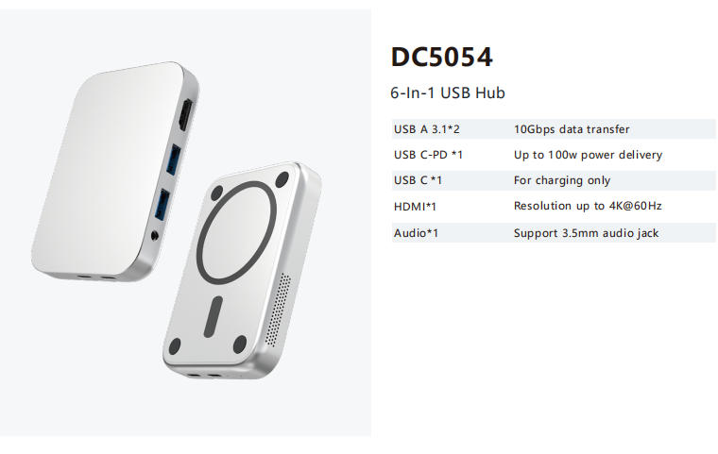
DC5054: Magnetic wireless charging compatible 6-in-1 mini hub, 2×10Gbps USB-A, PD charging, HDMI4K60, audio jack.
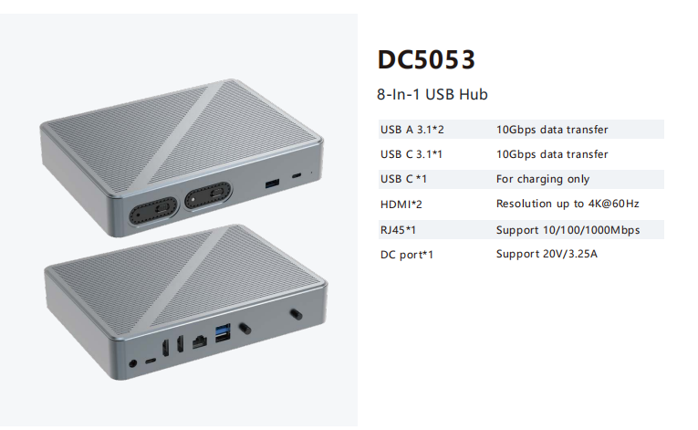
DC5053: 8-in-1 dual HDMI 4K60 dock with DC power input for heavy multi-peripheral loads.
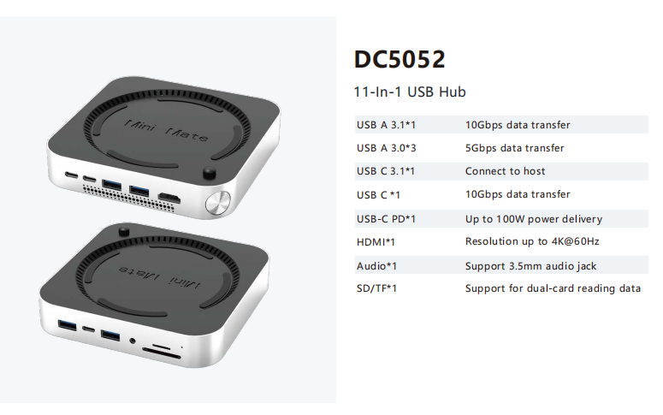
DC5052: Round desktop dock with physical power knob, 10Gbps high-speed USB, dual card reader, 100W PD, HDMI 4K60.
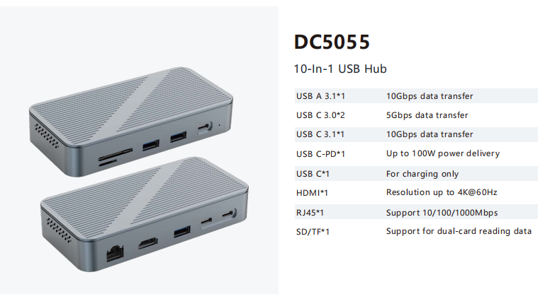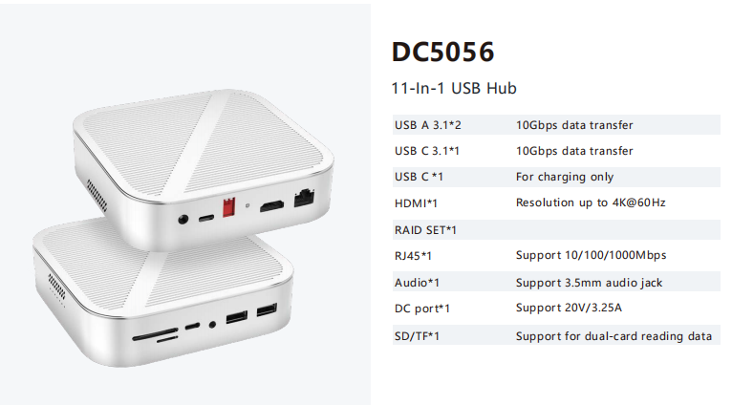
DC5055/DC5056: Square textured desktop docks with RAID hard disk slot option, Gigabit LAN, multi-speed USB ports, DC power input for stable all-day workstation use.

M2P11 | 12-in-1 Laptop Stand Integrated Hub

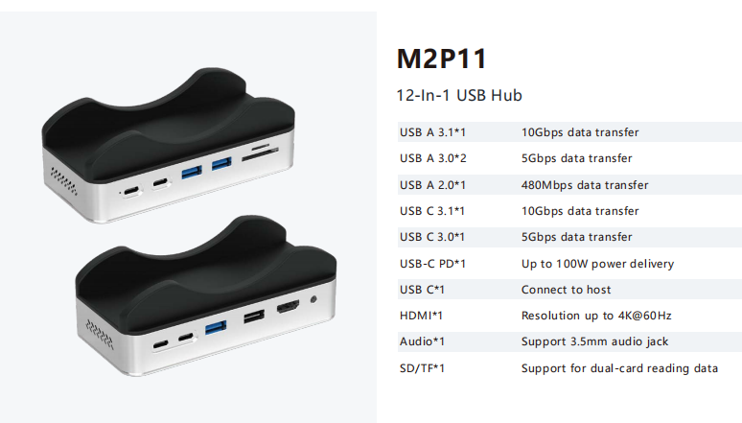
M2P11 12-in-1 Stand Hub
All-in-one laptop riser + expansion hub: multi-speed USB ports (10Gbps/5Gbps/480Mbps), 100W PD pass-through, HDMI4K60, 3.5mm audio, dual SD/TF card reader. Elevates laptop screen height for ergonomic typing while solving port shortage, a space-saving desk solution for office users.
Part 3: Powered Data-Only USB Hubs (YH / C1 Series, No Video Output)
YH6AC | 9-in-1 Powered USB-C Data Hub (No Video Output)

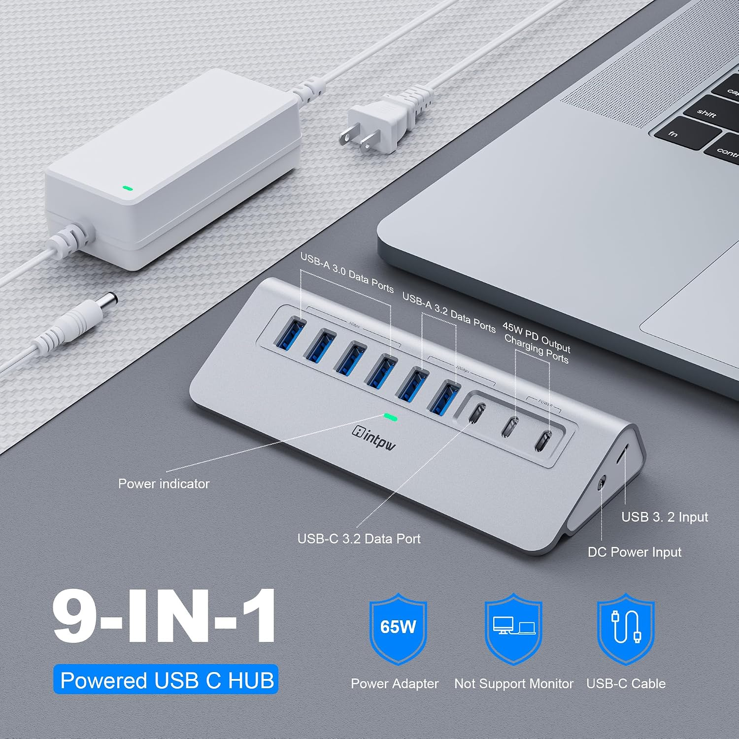
YH6AC 9-in-1 Powered Hub
Core Features
Mixed-Speed Multi-Port Data Splitter (Zero Video Function)
Port layout: 1×USB-C3.2 10Gbps, 2×USB-A3.2 10Gbps, 4×USB-A3.0 5Gbps, 2×USB-C PD 45W charging-only ports (no data transfer). Expand interfaces for laptops, desktops and game consoles, cannot drive monitors. Not recommended for charging high-power laptops.
10Gbps High-Speed File Transfer
USB3.2 ports hit 10Gbps bandwidth for ultra-fast large video/photo file transmission, ideal for video editors, photographers and researchers. Avoid connecting multiple SSDs simultaneously to prevent speed bottlenecks.
Independent 45W PD Auxiliary Charging Ports
Two dedicated 45W charging Type-C ports for iPhone 15/16/17, iPad and mobile devices; power adapter must be connected to activate charging function. PD ports carry data signals only.
Ergonomic Recycled Aluminum Design
32° tilted triangular aluminum chassis with stable support feet for easy plug/unplug; constructed with over 50% recycled materials. 65W UL/FCC certified DC power supply with built-in surge protection against overvoltage, overcurrent and short circuits.
Universal Cross-Device Compatibility
Comes with USB-C to USB-C host cable, compatible with M1-M5 MacBook Air/Pro, iMac, Dell XPS, Surface Pro and all full-function USB-C devices. Works with standard-sized USB-C flash drives and cables; custom thick-shell peripherals require compatibility consultation.
YH6AC-PLUS | 10-in-1 Powered Hub with SD/TF Card Reader
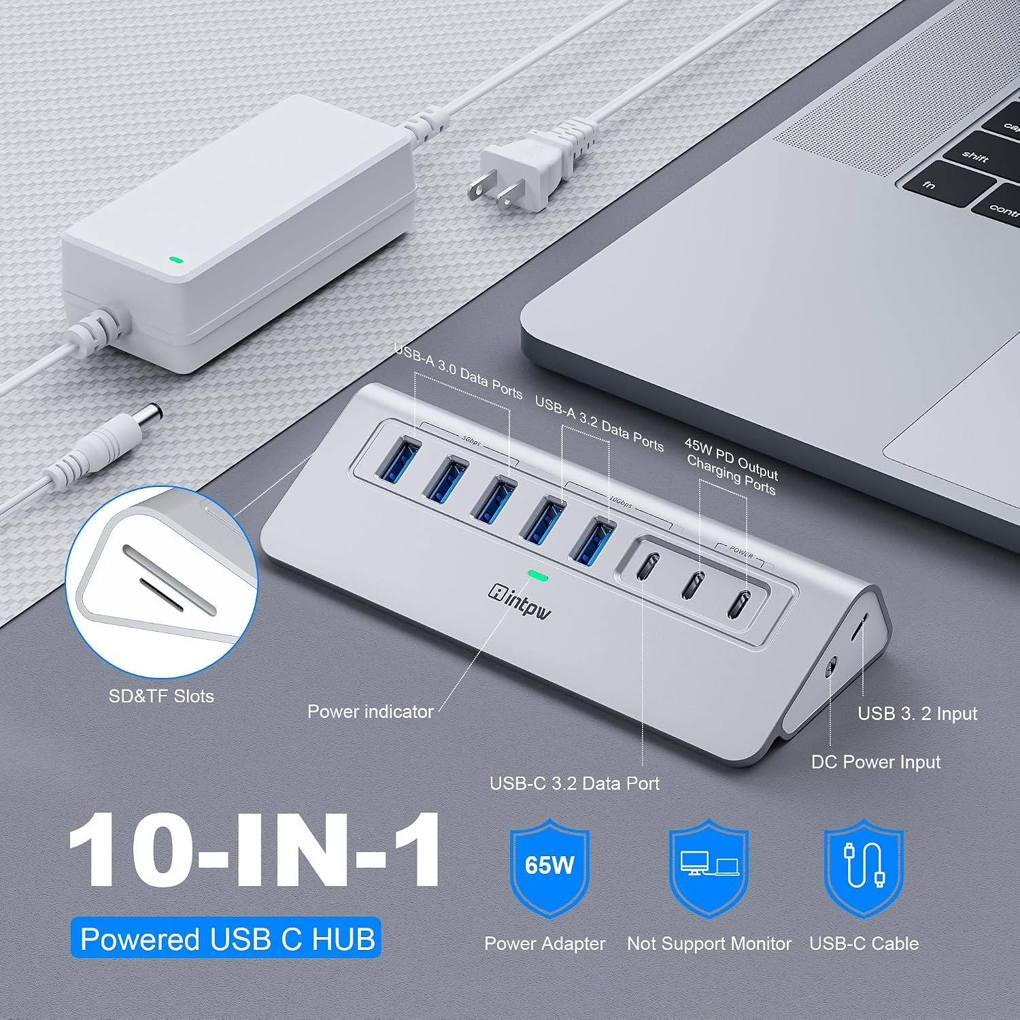

YH6AC-PLUS 10-in-1 Powered Hub
Upgraded version of YH6AC, adding integrated SD/microSD dual card reader (104MB/s read, 80MB/s write, simultaneous dual-card access). Perfect for photographers to offload footage without extra adapters, retains all original high-speed data and 45W PD charging functions, with 65W certified power supply for stable multi-device operation.
YH9AC | 12-in-1 High-Capacity Powered Data Hub

YH9AC 12-in-1 Powered Hub

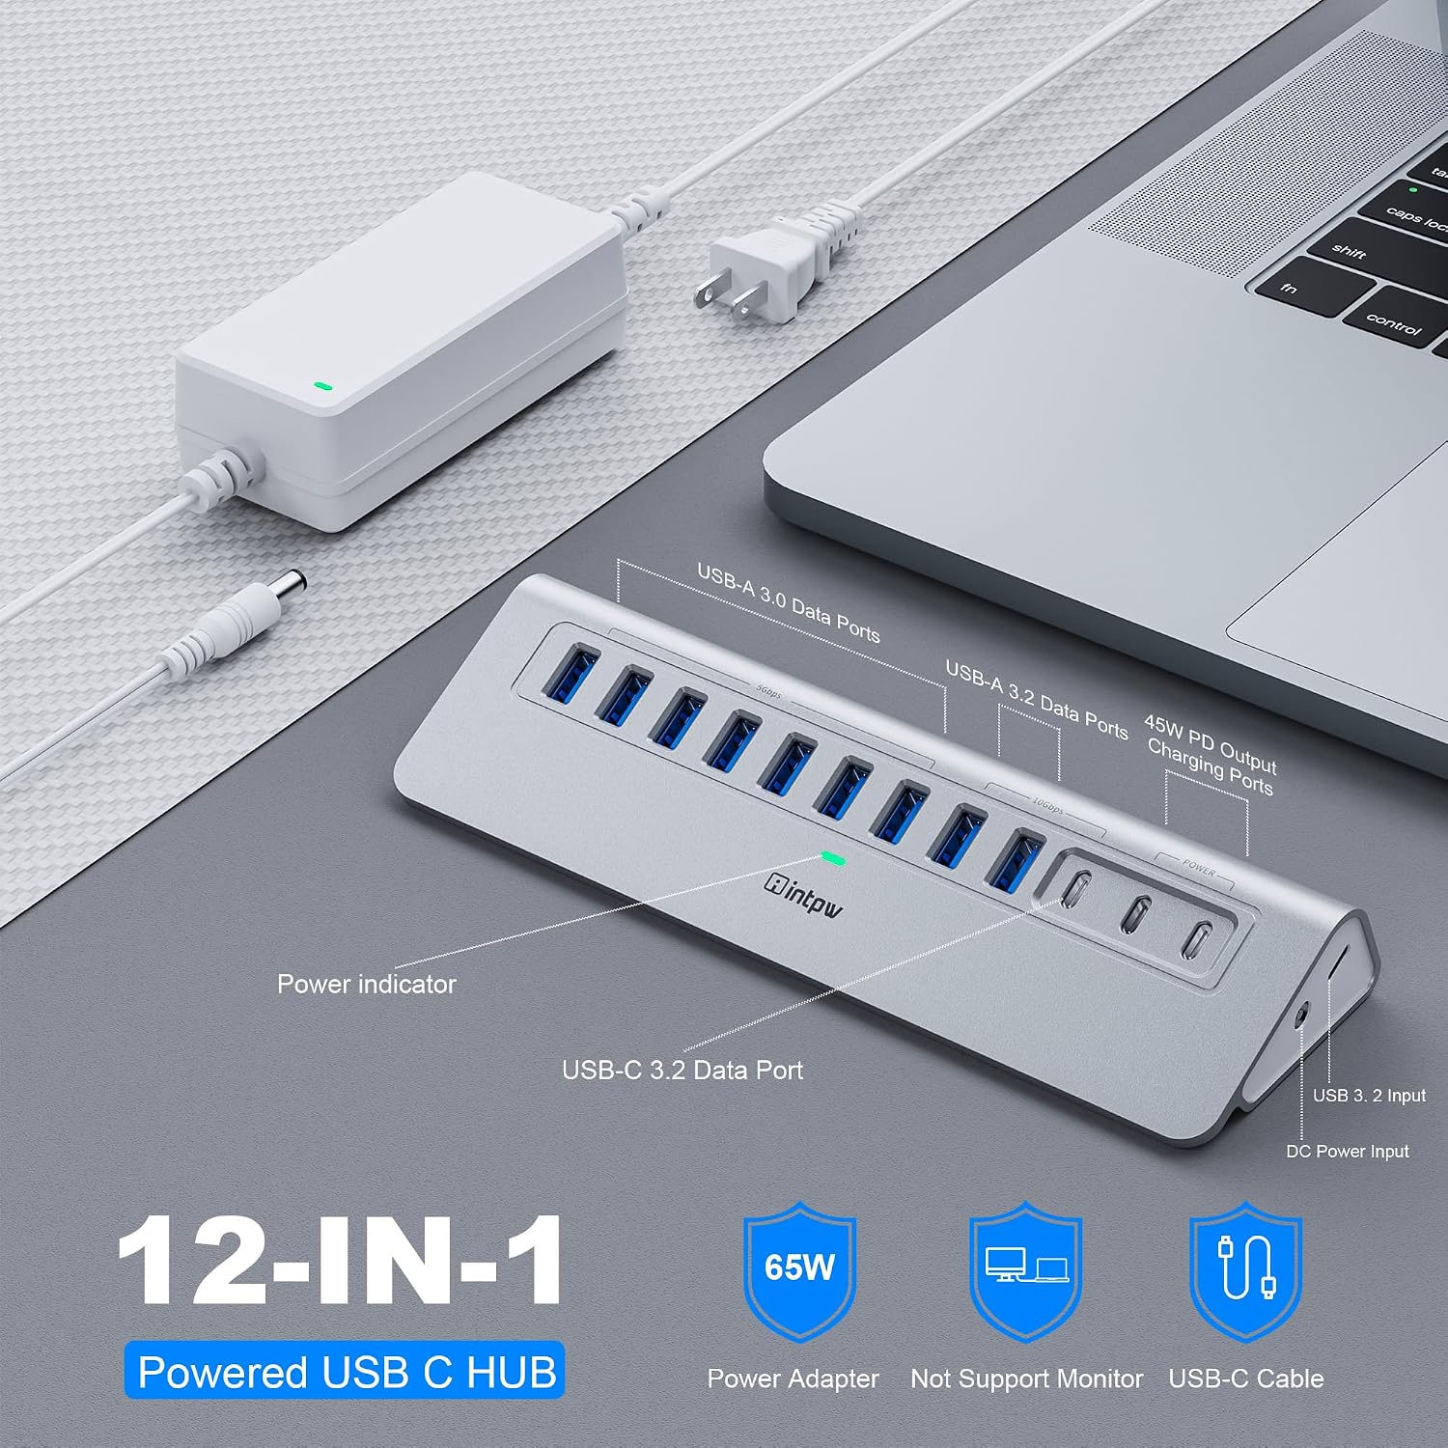
YH9AC Front Port View
Core Features
Massive port expansion: 1×USB-C3.2 10Gbps, 2×USB-A3.2 10Gbps, 7×USB-A3.0 5Gbps, 2×45W PD charging-only USB-C ports, no video output support.
Ideal for heavy peripheral setups: multiple external SSDs, keyboards, mice, drawing tablets and camera accessories all connected at once without power shortage.
Same 65W surge-protected power adapter, tilted aluminum heat-dissipating shell, wide compatibility for all USB-C notebooks and tablets.
C1 | 15-in-1 Premium Powered USB-C Hub (100W Laptop PD)
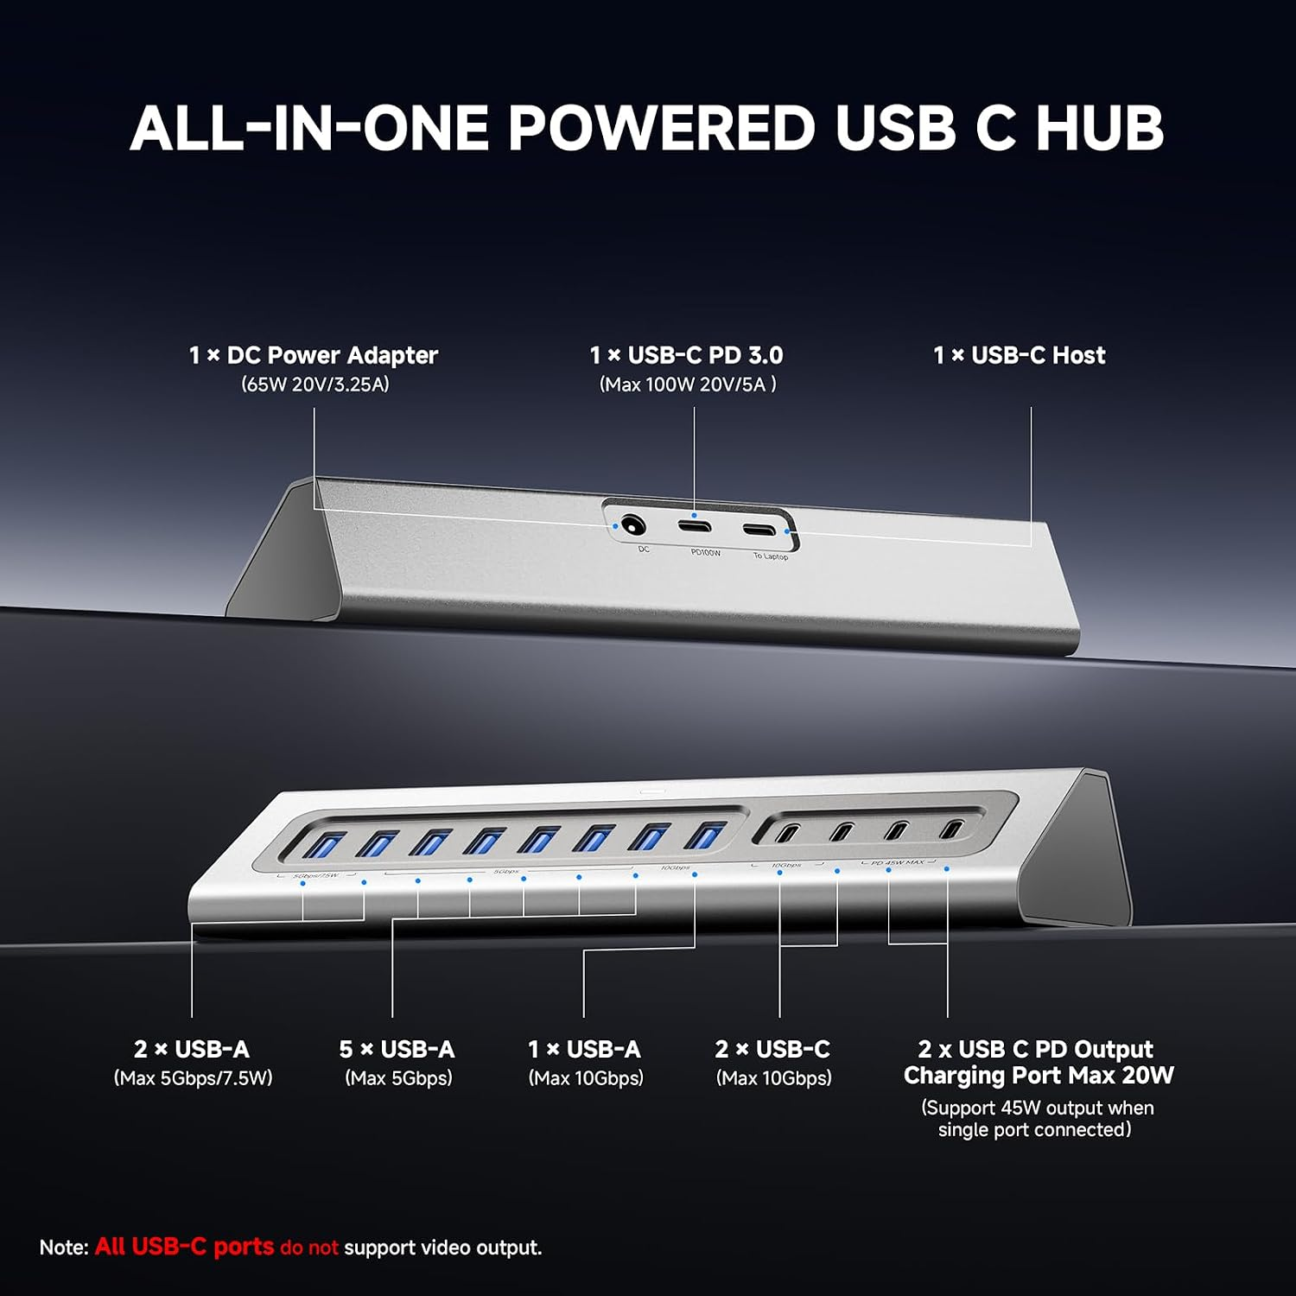
C1 15-in-1 Powered Hub Diagram
Core Features
15-Port All-Data Hub (No Video Output)
Port allocation: 1×100W USB-C PD laptop charging port, 2×45W auxiliary charging USB-C ports (single port 45W max, dual ports shared 20W), 2×USB-C3.2 + 1×USB-A3.2 10Gbps data ports, 5×USB-A3.0 5Gbps, 2×USB-A3.0 5Gbps/7.5W low-power charging. All ports cannot output video signals; 65W power adapter must be connected for full functionality.
Dual-Range PD Charging System
100W dedicated PD port charges your MacBook/Windows notebook directly via the hub.
Two independent auxiliary charging ports deliver up to 45W for mobile phones, tablets and wearables. Do not charge high-power laptops via auxiliary ports.
10Gbps Blazing-Fast Data Transfer
10Gbps USB3.2 ports offer 20× faster speeds than USB2.0, cutting large video backup time drastically for video creators, photographers and IT professionals.
Heat-Optimized Ergonomic Aluminum Body
Solid aluminum alloy for excellent passive heat dissipation, trapezoidal tilted design with anti-slip base for stable desktop placement. Built for long-hour professional creative and office workflows.
Broad Cross-Platform Compatibility
Compatible with Thunderbolt 3/4/5 and full-function USB-C devices: M1-M5 MacBook series, iMac, Mac Mini, Dell XPS, Surface Pro, iPhone 15/16/17, iPad Pro. Supports macOS 12+; incompatible with legacy USB-A/Thunderbolt 2 MacBooks. Plug-and-play, no driver installation required.
H5 Series 4-Port Pure USB Splitter
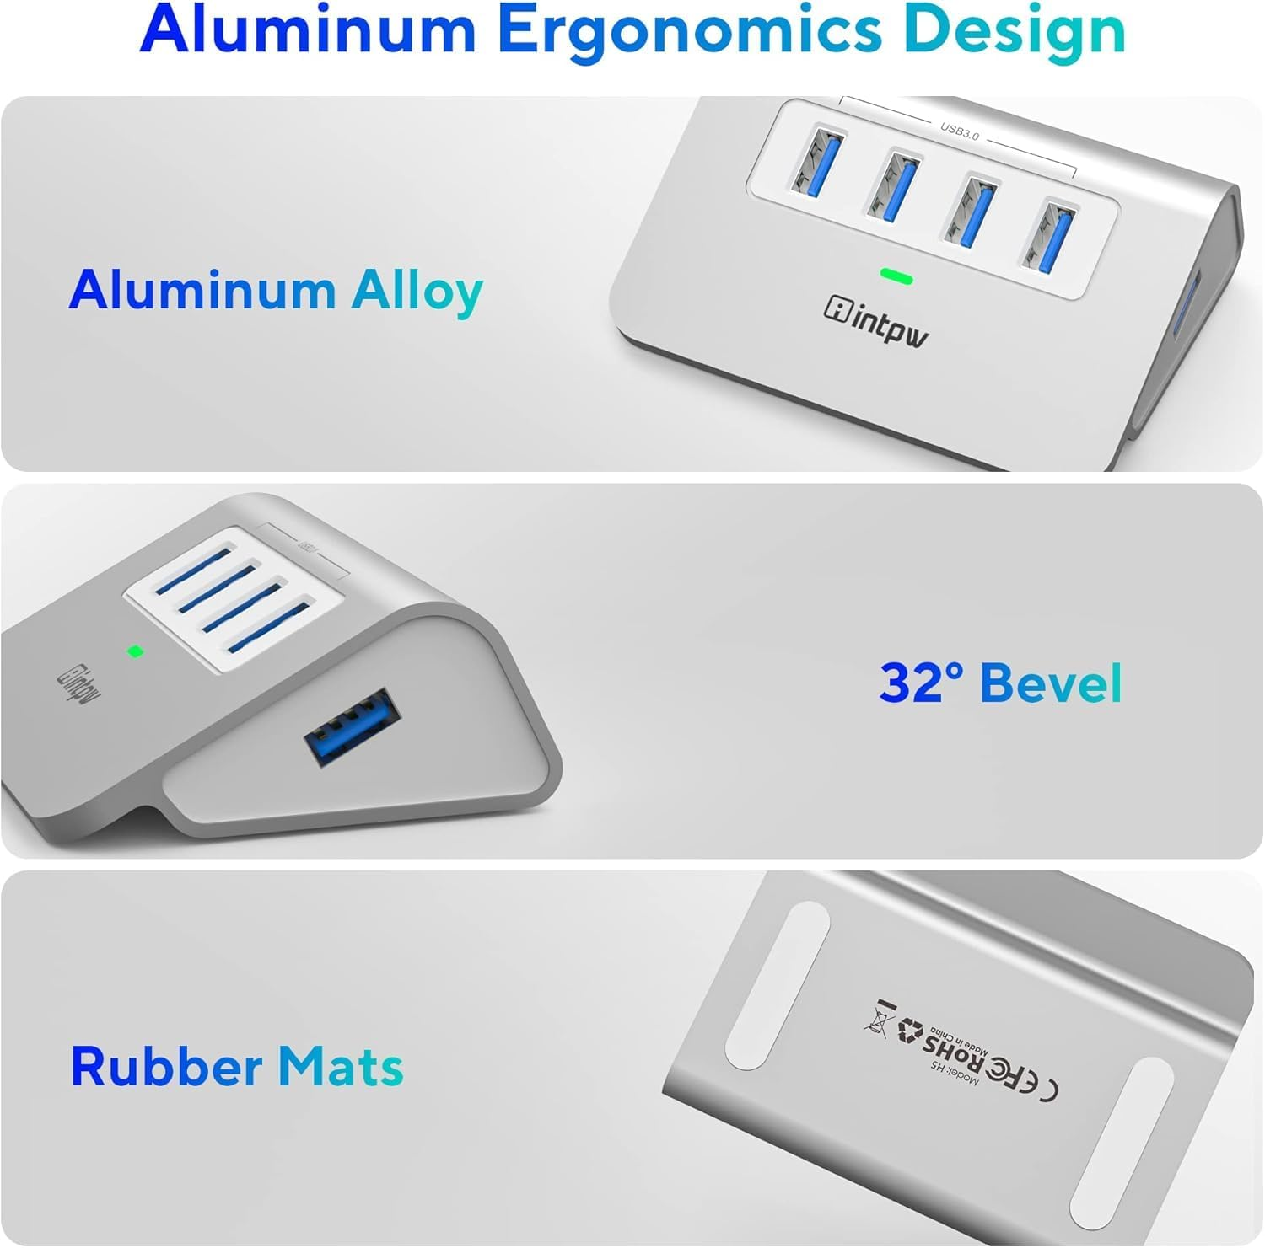

H5 4-Port USB Splitter
Simple 1-in-4 USB3.0 hub, 5Gbps transfer speed, hot-swap supported, plug-and-play without drivers. Aluminum 32° tilted design for heat dissipation, compatible with laptops, desktops, game consoles, USB flash drives, mice, keyboards and printers. External micro USB power input available for high-power peripherals.
Part 4: Special Functional Hubs
YH3AC | 13-in-1 Triple 8K/4K Display MST Hub with One-Touch Screen Off Button

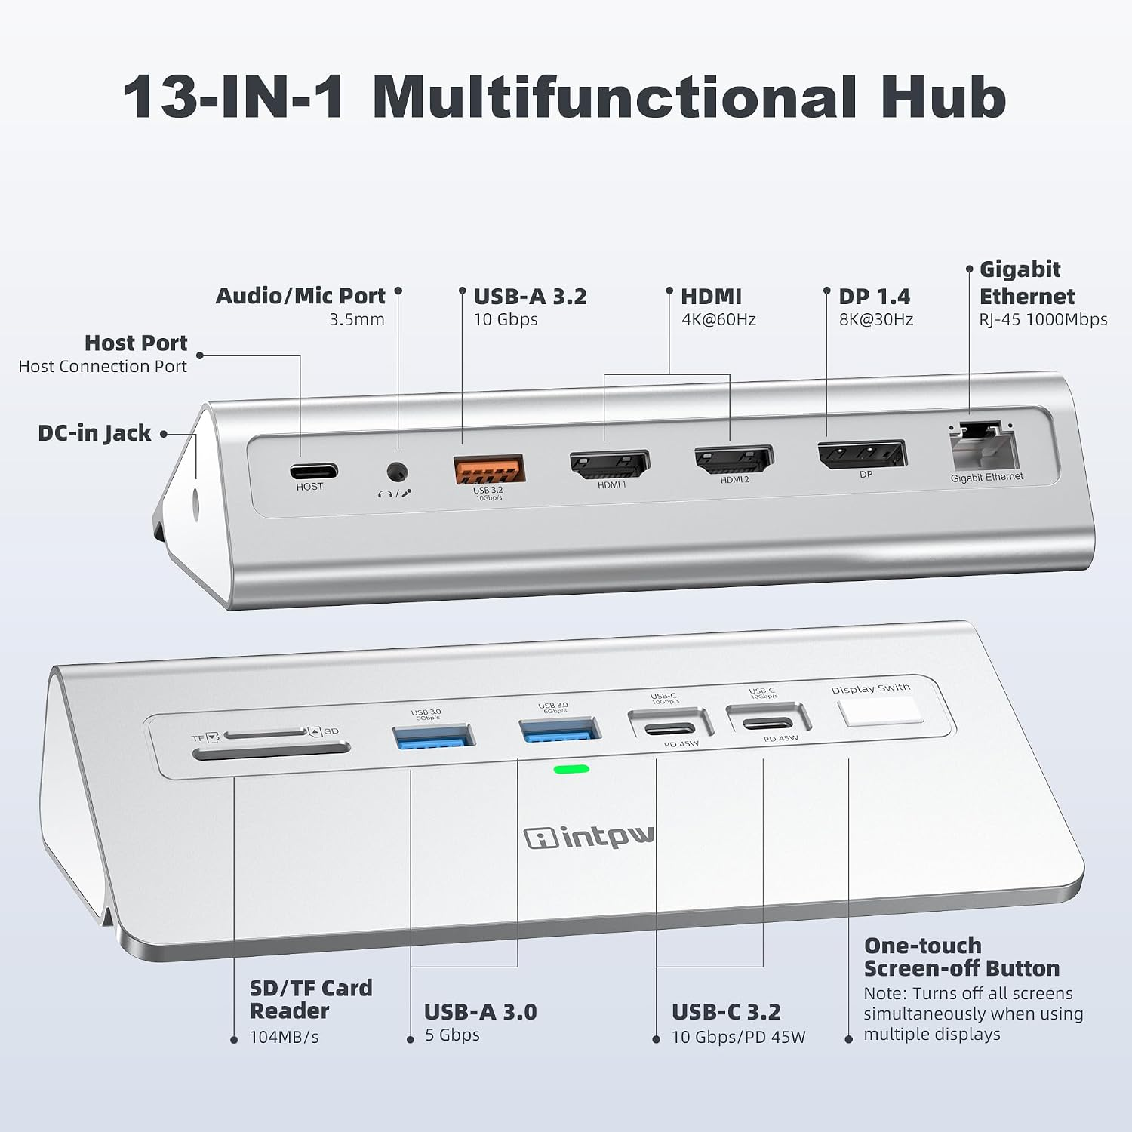
YH3AC 13-in-1 Triple Display Hub
Core Features
Triple Video Output: DP 8K@30Hz + Dual HDMI 4K@60Hz
Single DP port supports up to 8K@30Hz; dual HDMI ports run 4K@60Hz each. Triple-screen mode delivers 4K60 + 4K60 + 4K30 simultaneously via DP1.4 signal, tailor-made for video editors, graphic designers and programmers. Only supports MST extended mode on Windows; macOS only supports mirror mode, no triple extended display.
Complete Multi-Function Port Layout
1×USB-A3.2 10Gbps, 2×USB-C3.2 (10Gbps data + 45W PD charging each), 2×USB-A3.0 5Gbps, Gigabit Ethernet, SD/TF dual card reader (104MB/s), 3.5mm combo audio/mic jack, exclusive one-touch screen privacy button to instantly cut all external display signals.
Dual 45W PD Auxiliary Charging Ports
Two Type-C ports with separate 45W charging output (single port 45W max, two ports shared 20W), fast charging for iPhone, Apple Watch and Android mobile devices. 65W DC power adapter included to guarantee stable multi-screen output and peripheral operation.
High-Speed Data & Stable Wired Network
3×10Gbps high-speed USB ports, dual card reader for fast media import, 1000Mbps zero-lag wired LAN for video conferences and cloud file sync. Built-in separate audio input/output for podcasting and remote meetings without extra adapters.
Heat-Dissipating Aluminum Ergonomic Build
32° tilted triangular aluminum chassis with spaced ports to avoid plug interference, anti-slip bottom mats for stable placement. Wide compatibility with all DP Alt Mode Thunderbolt/USB-C notebooks, plug-and-play without extra drivers.
OM28PR | 12-in-1 Hub with Built-In M.2 SSD Enclosure (NVMe/SATA Dual Protocol)
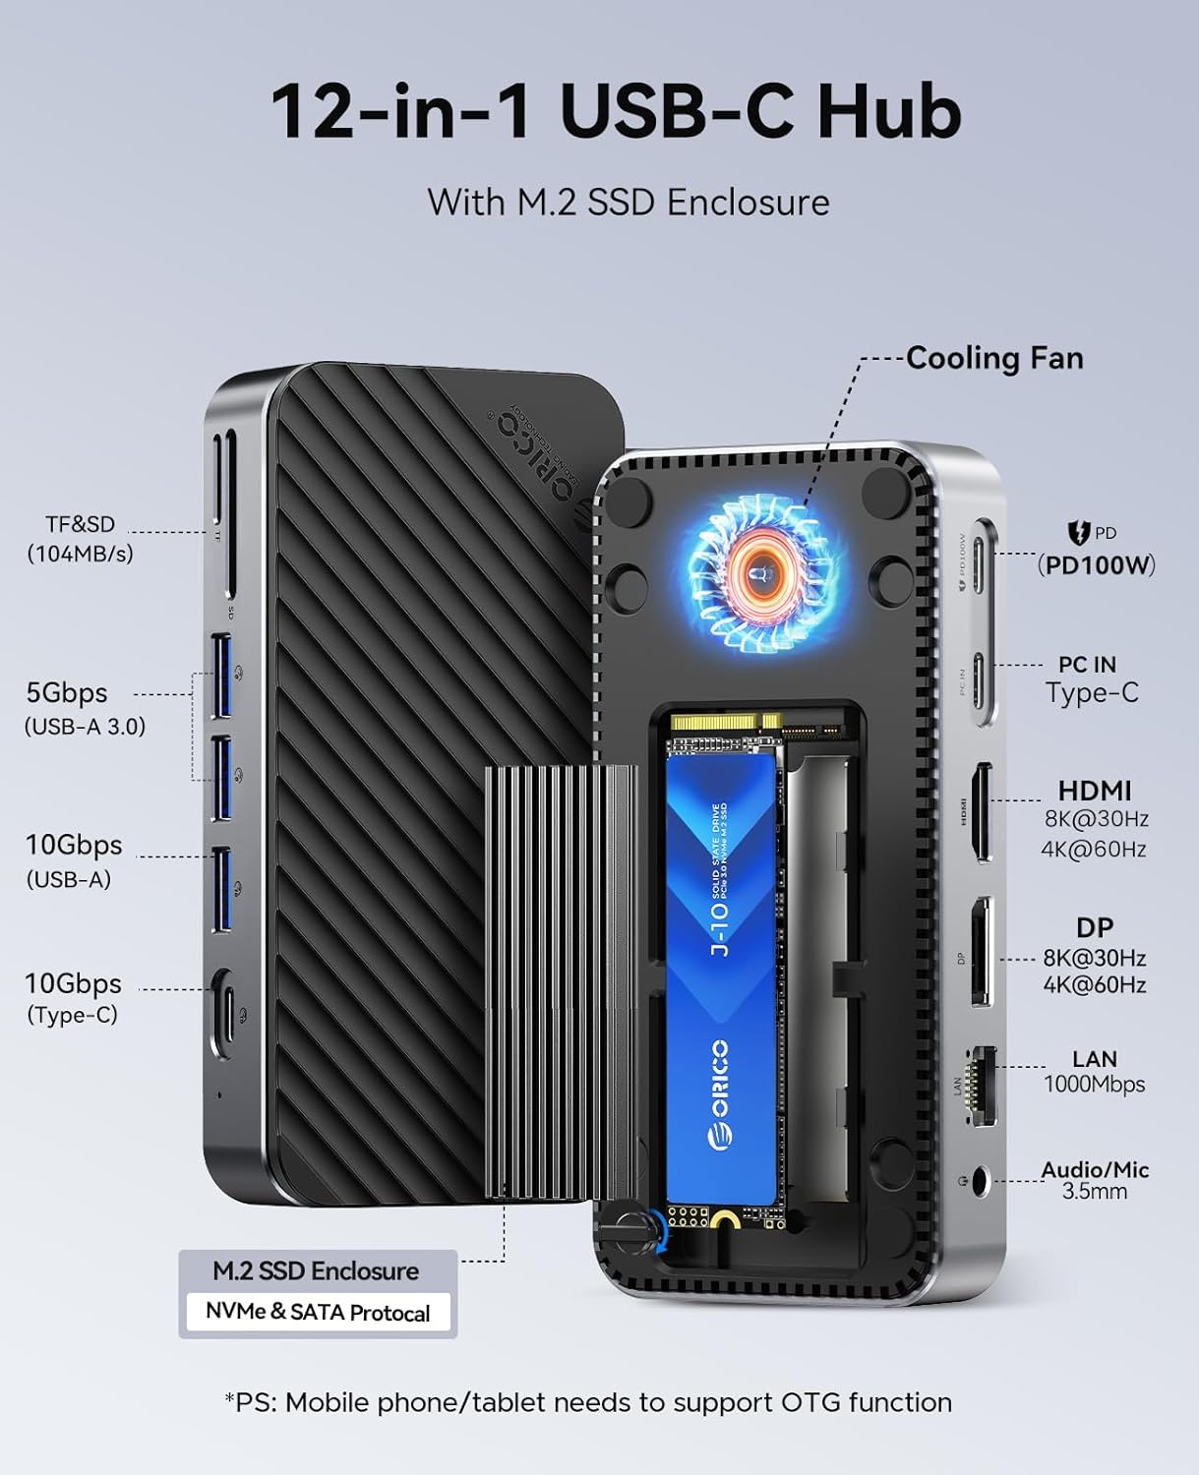

OM28PR M.2 SSD Hub
Core Features
All-in-One Expansion + M.2 Storage Dock
Integrates a detachable M.2 SSD enclosure supporting NVMe & SATA protocol M.2 drives, expand storage capacity up to 8TB (SSD sold separately; >1TB SSD requires external power supply). Combines video output, data transfer, card reader and charging functions in one single device.
8K Single / Dual 4K Extended Display Output
DP port supports single 8K@30Hz monitor; DP + dual HDMI combination enables two independent 4K@60Hz extended screens to boost multi-tasking efficiency for office and creative work. Actual resolution depends on host GPU performance.
Hierarchical High-Speed Data Transmission
10Gbps USB-C/USB-A ports for large raw video/file transfers, 5Gbps USB-A ports for daily low-power peripherals, SD/TF card reader for instant camera footage backup to cut waiting time.
Active Cooling Fan + 100W PD Pass-Through Charging
Built-in cooling fan and heat sink prevent SSD thermal throttling during long-duration read/write operations. 100W PD pass-through charging keeps your notebook powered while working, power adapter not included with the unit.
Wide Device Compatibility
Supports all full-function USB-C/Thunderbolt notebooks, mobile phones and tablets with OTG function, ideal for content creators, photographers and video editors needing portable high-capacity storage and multi-screen expansion.
Product Selling Points Summary (For Client Reference)
Diversified Product Lines
Covers all usage scenarios: professional multi-screen workstation docks for traders/designers, portable travel hubs for business users, powered data-only hubs for photographers/IT staff, special functional hubs with M.2 storage, laptop stand and magnetic wireless charging.
Multi-Grade Video Output Solutions
Options range from single 4K, dual 4K, triple 4K to quad 4K/8K ultra-high resolution; two technical routes: DP Alt Mode plug-and-play hubs & DisplayLink driver-based multi-monitor docks for Mac M-series screen expansion.
Complete Charging Solutions
Three charging categories: 100W PD pass-through portable hubs (use your own charger), built-in 120W/150W DC power supply professional docks, 65W powered data hubs with independent 45W auxiliary charging ports for mobile devices.
High-Speed Data Transmission Options
Mixed 10Gbps USB3.2 and 5Gbps USB3.0 port layouts for different cost demands; integrated SD/TF dual card readers up to 104MB/s read speed for creative industry users.
Ergonomic Premium Aluminum Design
All main models adopt brushed aluminum alloy casing for superior heat dissipation; 32° tilted anti-slip design for easy plug/unplug; vertical tower, square desktop, slim portable and laptop stand form factors to fit all desk layouts.
Cross-System Global Compatibility
Fully compatible with Windows, macOS, Chrome OS, Android and Ubuntu systems; supports Thunderbolt 3/4/5, USB4 and all full-function USB-C notebooks, covering mainstream brands including MacBook, Dell XPS, Lenovo ThinkPad, HP, Surface.
Value-Added Exclusive Functions
Unique features across product series: physical volume adjustment knob, one-touch screen privacy off button, built-in M.2 SSD cooling enclosure, vertical tower space-saving design, magnetic wireless charging compatible chassis, laptop riser integrated hub, independent power control switch for all peripherals.

